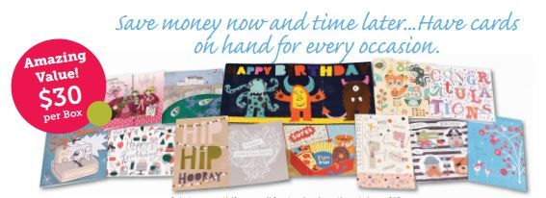

Student's Name ________________________ Classroom Teacher _________________________

Tired of spending too much money for greeting cards? How does $1.00 per card sound? Order forms & payment due October 11. Questions? Contact Karen Goelz at: karen.goelz@muskegonorway.org If you are purchasing the cards for your family only, fill out row 1. If you are selling to family, neighbors, friends etc… use the additional rows.

Name | All Occasion Box 1  (Green) | All Occasion Box 2  (Blue) | Thanks & Blanks | The Kids Birthday Box | Total Number of Boxes | Total Cost (Each box is $30)
Totals:

